**API Documentation**

**GET: Get the session using its session ID and ownerID.**

Returns sessionId, ownerId and status of session (start (1) or stop(0) ).

**GET: Get a question using its questionid and sessionid**

Returns the questionId, questionPosted, answered status( yes(1) or no(0) ) and isStarted status ( yes(1) or no(0) ).

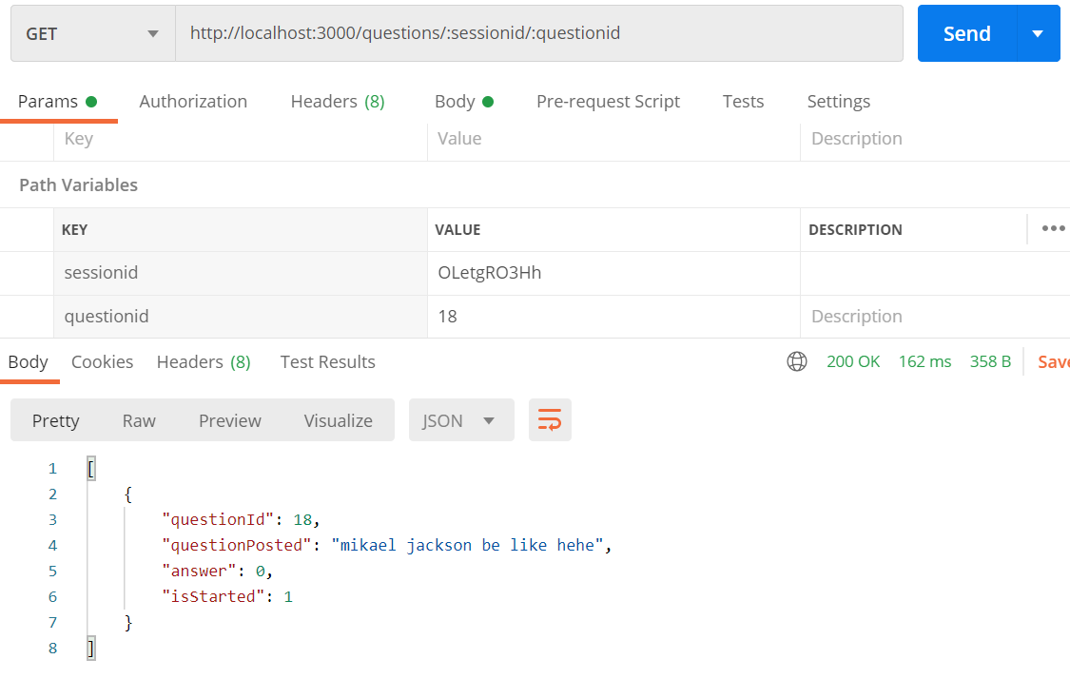

**GET: Get all questions in specified sessionid**

Returns the questionid, questionPosted and isStarted status( yes(1) or no(0) )

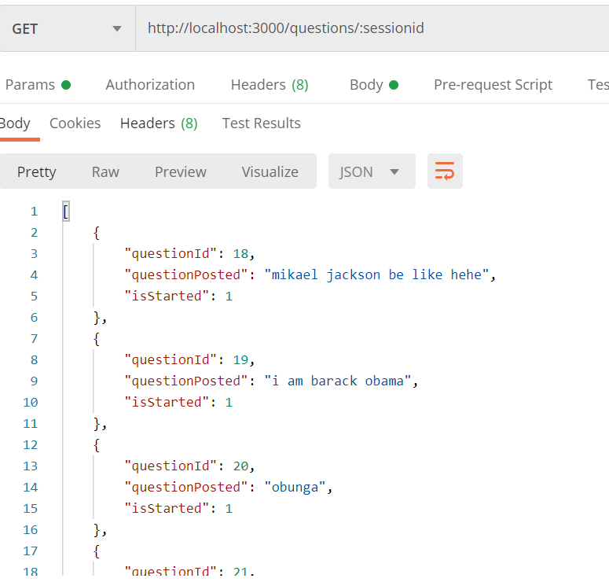

**POST: Post a new session**

Inserts values of sessionId, ownerId, isStarted into the session table

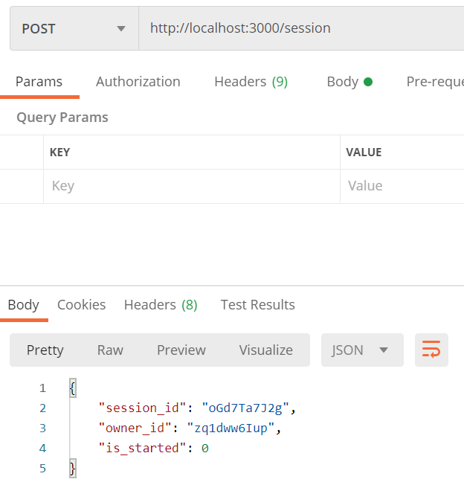

**POST: Post a new question in a specified session**

Insert values of sessionId, questionPosted and answer into questions table

If successful, return ‘Question Posted’ message.

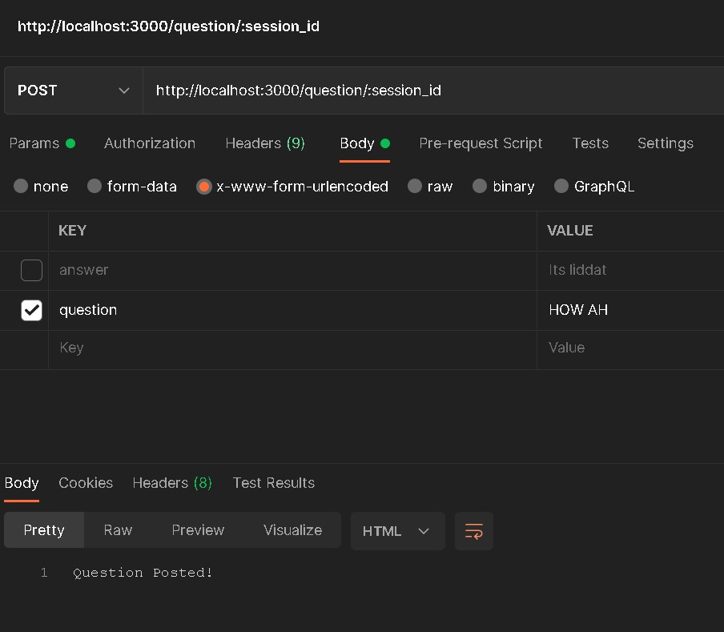

**PUT: Put a new answer for a question in a specified session**

Insert answer value from query body into questions table

If successful, return ‘Answer Posted’ message.

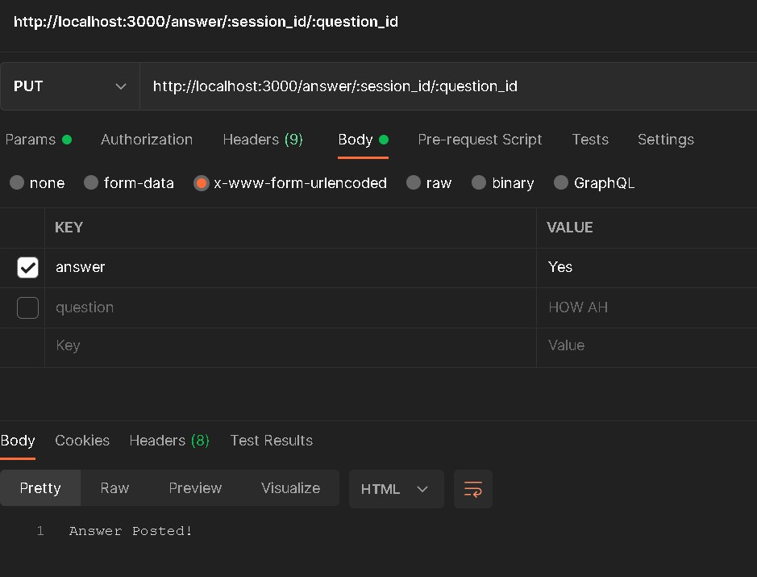

**UPDATE: Starts Session**

Puts value of 1(Start) into the isStarted column of the session table.

If successful, return ‘Session Started!’ message.

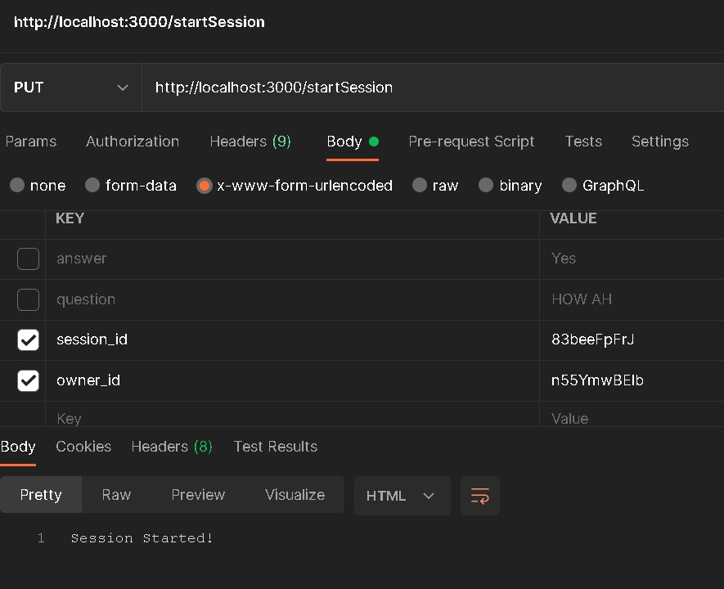

**UPDATE: Stops Session**

Puts value of 0(Stop) into the isStarted column of the session table.

If successful, return ‘Session Stopped!’ message.

